  

**SOW**

**for**

**PI/PO Interface Migration**

for

Haceb

Submitted on: 15 August 2024

Version: 1.0

By:

Crave InfoTech

15 Corporate Place South

Suite104

Piscataway, NJ-08854

Point of Contact:

**Shrikant Nistane**

Contact: +1 253 241 6704

[Email: Shrikant@craveinfotech.com](mailto:Email:%20Shrikant@craveinfotech.com)

**Kalpana Parekh**

Contact: +1 416 688 0297

[Email: Kalpana@craveinfotech.com](mailto:Email:%20Kalpana@craveinfotech.com)

Table of Contents

1. Executive Summary 3

2. Objective 4

Objective 4

3. Scope and Out of Scope 5

In Scope: 5

Migration Project Prerequisites: 5

Assumptions: 5

Out of Scope: 5

4. Implementation Approach & Timelines 6

Migration Methodology from PI PO to Integration Suite 6

Proposed Timeline – 17 weeks 7

5. Responsibility Matrix 8

6. Resource Schedule, Charges and Payment Terms 9

Resource Schedule 9

Commercials: 9

Timesheet, Invoices and Payment Terms 10

7. Governance (Meetings/Steercos/Escalation Path) 11

Communication Plan 11

Issue Resolution and Escalation Procedure 11

8. Sign Off 13

9. Appendix 14

# Executive Summary

Crave InfoTech is pleased to submit proposal for the PI/PO Integration Migration. We greatly appreciate the opportunity to present our vision on how Crave InfoTech will enable Haceb to achieve its stated end-state vision by strategically aligning ourselves to meet Haceb both immediate and longer-term business objectives.

Haceb has taken a strategic decision to migrate from SAP PI/PO to SAP Integration Suite.

Crave InfoTech has been closely associated with SAP since 2007 and has earned the confidence of clientele across North America, Africa, Australia and Asia as an Independent Software Solutions Vendor (ISSV). Over the years, companies from the public and private sectors have turned to us for our expertise, dependability, flexibility and collaborative approach to achieve their business objectives.

We continue to grow with our wide range of standard and tailor-made solutions that come with an ISO 9000 quality assurance. Our highly skilled, dedicated and motivated workforce, stationed at our headquarters in New Jersey (USA) and development centres in Pune and Nagpur (India) strive to deliver high quality services in the following mobility technologies:

* SAP Certified Interface Migration Factory Partner
* SAP Fiori Application development
* SAP Enterprise Asset Management
* SAP ECC
* SAP S/4 HANA
* SAP Business Technology Platform
* SAP Asset Manager
* SAP EWM
* Mobile Device Management
* AI, ML & GenAI
* SAP MDK

Crave InfoTech has supported multiple client organizations globally including both the public sector and private sector companies. These companies have relied upon Crave InfoTech’s experience, trustworthiness, reliability, flexibility and collaborative approach for achieving their business objectives.

About Crave InfoTech:

Crave InfoTech’s customers have been utilizing our 50+ pre-packaged and tailor-made business solutions since 2007, calling us “An innovative, rapid, and agile partner” as well as “An essential element in the story of their business.” Crave InfoTech is an Independent Software Solutions Vendor (ISSV), SAP Value Added Reseller and member of Global SAP Partner Edge Build program with expert technocrats at our helm. We’ve been closely associated with SAP since our founding in 2007, were selected as SAP Pinnacle Award Finalist (one of the top 44 partners globally) and have earned the confidence of clientele across North America, Africa, Australia and Asia.

# Objective

Objective

The primary objectives of this project are: *Migrate from the current PI/PO integration Platform to the SAP Integration Suite*

**The below table states the interface configuration objects (ICO) which need plan to be migrated.**

|  |  |
| --- | --- |
| **No.** | **Migration of ICOs from SAP PI/PO to SAP Integration Suite as per details below** |
| **1** | **No of Interfaces to be migrated from SAP PI/PO to SAP Integration Suite: 113** |

**\*\*Interfaces Configurations Objects (ICOs) are listed in the Appendix**

# Scope and Out of Scope

In Scope:

* Migration of interfaces from SAP PI/PO to SAP Integration Suite cloud integration
* Total ICOs – 113

Migration Project Prerequisites:

* SAP Cloud Connector must be setup, provisioned, sized and is made available by Haceb.
* Typical tasks to be performed with support by a migration team. SAP Integration Suite tenants are setup, available and configured.
* Access to SAP PI/PO system and interfaces will be made available during the project. Haceb Team needs to provide necessary VPN access to connect to their on-premise system.
* Haceb IT Team SME to provide additional insight and support for SAP PI/PO landscape
* Changes in the PO interfaces (if needed) should be done prior migration starts.
* Installing FIGAF Tool for Testing (Optional).
* If choose File Adapter availability, Edge Integration Cell is required.

Assumptions:

* Haceb to provide the access to the system for migration team during the requirement analysis phase.
* Haceb Team shall identify SPOC for functional/technical clarifications who would be empowered by client to make decisions on behalf of the function they represent SPOC would be made available as per the detailed project plan that will be developed and shared during the Project Preparation phase for this engagement.
* UAT is the responsibility of the Haceb team All necessary personnel and resources to execute activities associated with testing will be the responsibility of the Haceb. Migration team will provide input into the development of the testing strategy.
* API already exists and no changes in API is needed for interfaces where there is API based integration
* Any change in API will impact the duration of the project.
* Source and target systems are made available for development and testing.
* Functional and technical specs will be provided during the project kick start.
* ABAP work (If required) will be taken care by Haceb team.

Out of Scope:

* New interface development/configuration of Interfaces.
* Testing of new interfaces or pre-packaged content.
* Enhancements on migrated interfaces.
* Required changes to ECC, S/4HANA or systems other than SAP Integration Suite.
* Custom error handling, alerts/logging.
* Transport Management approach/changes

# Implementation Approach & Timelines

Crave InfoTech's migration methodology has been incorporated with multiple implementation experiences. Our methodology is based on lean principles and adapts to implementation needs. We have delivered multiple BTP projects successfully with this approach.

Migration Methodology from PI PO to Integration Suite

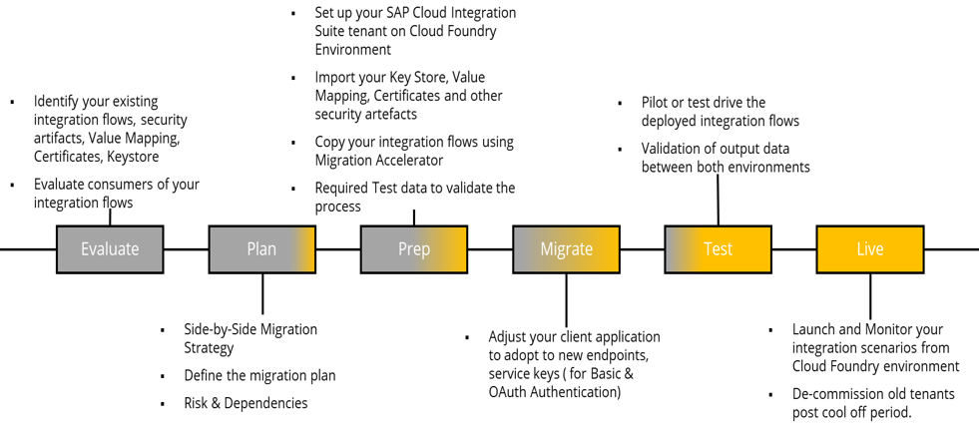

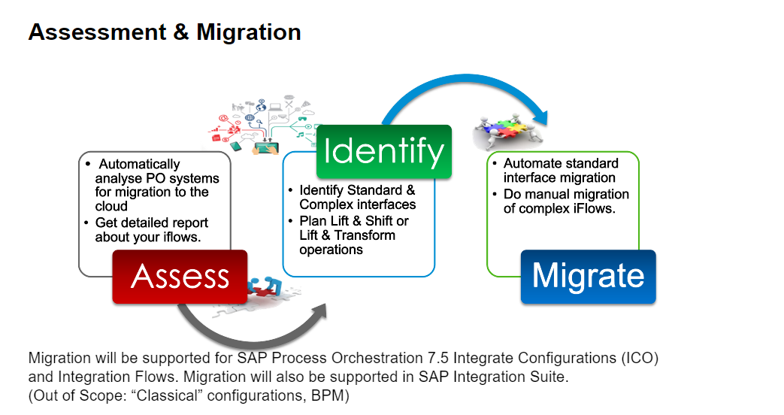

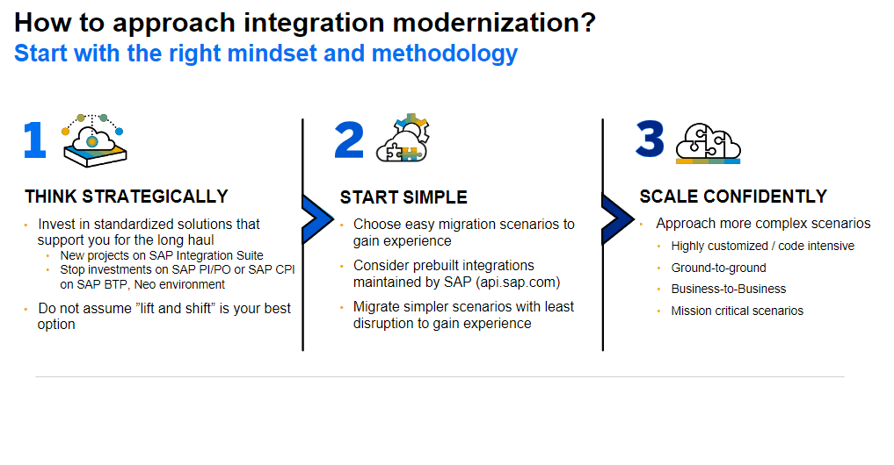

Proposed Timeline – 12 weeks

  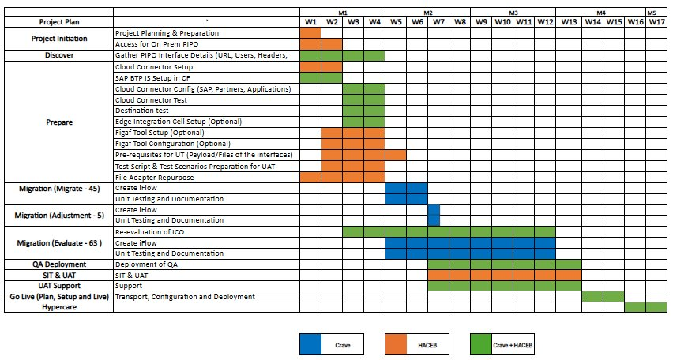

# Responsibility Matrix

The definition of the responsibilities of the team members in the delivery organization including Crave InfoTech and Client Organization is critical to the project's success.

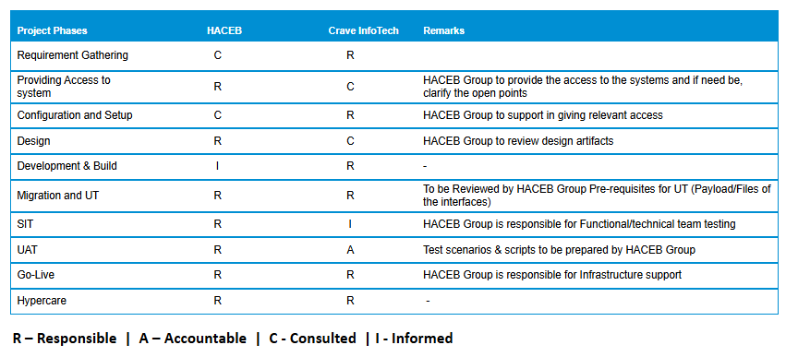

# Resource Schedule, Charges and Payment Terms

Resource Schedule

Crave Infotech proposes to deploy following team with their indicative loading based on

current understanding –

|  |  |  |  |
| --- | --- | --- | --- |
| **Crave Infotech Resources** | **Location** | **Allocation** | **Resource Count** |
| Project Manager | Onshore | Fulltime | 1 |
| Integration Developer | Onshore | Fulltime | 1 |
| Integration Developer | Offshore | Fulltime | 3 |
|
| Business Analyst | Offshore | Fulltime | 1 |

Recommended team from Haceb who need to be available during the project execution

|  |  |  |
| --- | --- | --- |
| **Client Resources** | **Allocation** | **Resource Count** |
| Project Manager | Partial | 1 |
| SAP IT/Basis | Partial | 1 |
| Solution Architect | Partial | 1 |  |
| Integration Specialist | Partial | 1 |  |
| Business Analysts/Functional SME from resp. areas | Partial | 1 |  |
| ABAP (If required)​ | Partial | 1 |  |

Commercials:

We propose to execute this project on T&M basis. Following is the resource estimation and indicative of total cost:

**Cost:** $ (17 Weeks)

**Any new enhancements or changes identified during the project phase will be considered a change request and will be estimated separately

**Note:**

* Resource, time and fee estimates are based on scope & assumptions stated in our proposal.
* For onsite activities, travel, lodging and expenses will be billed at actuals.

Timesheet, Invoices and Payment Terms

* Invoices will be submitted bi-weekly for the actual time incurred during that period as per the resource schedule in the section Scope
* Payment to be released within 30 days from the date of submission of invoices.
* Resource, time and estimated cost are based on scope & assumptions stated in our proposal.
* Onsite activities are not planned as part of this project, but if needed, must be agreed upon by both parties in writing prior to those activities and must adhere to customer’s terms for preferred Airline flights and lodging.

# Governance (Meetings/Steercos/Escalation Path)

Communication Plan

Following table represents different reports that will be generated periodically and circulated to various stakeholders.

| Exhibit: Daily Interaction | | | | |
| --- | --- | --- | --- | --- |
| Activity | Communication Mode | Report Recipient/s | Frequency | Comments |
| Weekly Status Reports | Email | Crave InfoTech Project Manager and Haceb Project Manager | Weekly | Summarize the tasks delivered & issues from the previous week(s), activities planned for the next week & specific events.  Project Effort and Schedule Variance |

Additional meetings will be decided during project planning phase as necessary.

Issue Resolution and Escalation Procedure

Crave InfoTech’s Project Manager will identify and capture project related issues that adversely impact the project, launch relevant actions to resolve them, and track and monitor the issues to closure. The Crave InfoTech’s Project Manager will also decide on the appropriate escalations for any critical/unresolved issues.

The responsibilities / timescales for executing these procedures are:

| Issue Management | | |
| --- | --- | --- |
| Task | Timescale | Responsibility |
| Raise Issue Report | As they occur | Any person working on or related to the project |
| Assessment/ Management of issues | Weekly/periodically | Crave InfoTech Project Manager |
| Reporting | Periodically | Crave InfoTech Project Manager |

Following guidelines will be followed for reporting the issues:

* Develop issue report containing problem description and suggested solution. Report to Crave InfoTech Project Manager
* Issues will be documented in issue reports and in the project’s issue log.
* The Crave InfoTech Project Manager is responsible for problem classification together with the issue reporter
* The Crave InfoTech Project Manager will convey the issue to the issue owner and define actions. If the problem is serious or critical, an issue report will be sent with a meeting invite
* The Crave InfoTech Project Manager assign the action to the issue owner or/and action owner
* The Crave InfoTech Project Manager will monitor and follow up the action plan
* The Crave InfoTech Project Manager will terminate the problem handling process when the problem is solved or decided closed

Following exhibit explains the process of issue classification:

| Issue Classification | | | |
| --- | --- | --- | --- |
| Problem Type | Definition | Reporting process | Solution Responsible |
| **Low** | Implies none or low project delay and/or cost increase. | Report to Crave InfoTech Project Manager. Issue handled within the project. | * Crave InfoTech Project Manager |
| **Serious** | Implies serious project delay and/or cost increase or influence on working relation. | Report to Crave InfoTech Project Manager and Crave InfoTech Account Executive. Inform Haceb Project Manager responsible | * Crave InfoTech Project Manager * Haceb Project Manager |
| **Critical** | Implies critical treat against the project or working relation. | Immediately report to Crave InfoTech Project Manager, Crave InfoTech Account Executive and the member of the Project Core Committee including Haceb Project representative | * Crave InfoTech Project Manager * Haceb Project Manager |

Following escalation process will be followed as part of the issue management:

| Exhibit: Escalation Process | | | |
| --- | --- | --- | --- |
| Issue Type | Escalation Point | Escalation Criteria | Governance Role (Project Core Group) |
| Project Delivery | Crave InfoTech Project Manager | If plan to resolve the issue is not outlined within 48 hrs (24 hrs in case of urgent issues) | Weekly checkpoints (or depending on the urgency)  Issue resolution  Quality issues |
| * Contract * Unresolved delivery issue * Program Management issue within specified timeframe | Crave InfoTech Account Executive | If plan to resolve issue is not outlined within 48 hrs (24 hrs in case of urgent issues) | Monthly Review  As needed in case of urgent issues |

**\*\*** The Project Workgroup will be comprised of representatives from Crave InfoTech and Haceb key project stakeholder.

# Sign Off

IN WITNESS WHEREOF, Crave InfoTech and Haceb have each caused this Project Proposal to be executed by their respective duly authorized officers as of the Effective Date.

The undersigned agree to the terms of this proposal on behalf of his or her organization or business.

Haceb Crave Infotech

By: By:

**Authorized Signature**   **Authorized Signature**

**Name:**  **Name:** **Vrushali Nistane**

**Date:**  **Date:**

# Appendix

|  |  |  |  |  |  |  |  |
| --- | --- | --- | --- | --- | --- | --- | --- |
| Sr no | | Integration Interface | | Current status | | Assessment Category | |
| 1 | | |HAQ_200_Q|TranspOrdSCMExecDelivAssgnmntChgdNotif_Out|http://sap.com/xi/APPL/Global|| | | In-Use | | Ready to migrate | |
| 2 | | |HAQ_200_Q|DocumentoPago_Integrales|urn:haceb.com:ap|| | | In-Use | | Ready to migrate | |
| 3 | | |CONCUR_Q|conn_test_out|urn:haceb.com:concur:test|| | | In-Use | | Ready to migrate | |
| 4 | | |DPM_108_D|InboundDeliveryCreateRequest_Out|http://sap.com/xi/TMS/Global|| | | In-Use | | Ready to migrate | |
| 5 | | |HAQ_200_Q|SLO_TransportationRequestSUITECancellationRequest_Out|http://sap.com/xi/APPL/Global2|| | | In-Use | | Ready to migrate | |
| 6 | | |HAQ_200_Q|PAG_TransportationRequestSUITECancellationRequest_Out|http://sap.com/xi/APPL/Global2|| | | In-Use | | Ready to migrate | |
| 7 | | |HAQ_200_Q|DocumentoPago|urn:haceb.com:ap|| | | In-Use | | Ready to migrate | |
| 8 | | |DPM_108_D|OutboundDeliveryBulkCreateRequest_Out|http://sap.com/xi/TMS/Global|| | | In-Use | | Ready to migrate | |
| 9 | | |INTEGRATION_ENGINE_JAVA_HPQ|DocPagoDavivienda_Out|urn:haceb.com:bpm|| | | In-Use | | Ready to migrate | |
| 10 | | |HAQ_200_Q|PAG_TransportationRequestSUITERequest_Out|http://sap.com/xi/APPL/Global2|| | | In-Use | | Ready to migrate | |
| 11 | | |HAQ_200_Q|TranspOrdSCMExecItmPckgAssgnmtChgdNotif_Out|http://sap.com/xi/APPL/Global|| | | In-Use | | Ready to migrate | |
| 12 | | |HAQ_200_Q|ODP_TransportationRequestSUITERequest_Out|http://sap.com/xi/APPL/SE/Global|| | | In-Use | | Ready to migrate | |
| 13 | | |INTEGRATION_ENGINE_JAVA_HPQ|DocPagoBcoBogota_Out|urn:haceb.com:bpm|| | | In-Use | | Ready to migrate | |
| 14 | | |INTEGRATION_ENGINE_JAVA_HPQ|DocPagoCitibank_Out|urn:haceb.com:bpm|| | | In-Use | | Ready to migrate | |
| 15 | | |HAQ_200_Q|OutboundDeliveryBulkConfirmation_Out|http://sap.com/xi/APPL/Global2|| | | In-Use | | Ready to migrate | |
| 16 | | |HAQ_200_Q|IDP_TransportationRequestSUITERequest_Out|http://sap.com/xi/APPL/SE/Global|| | | In-Use | | Ready to migrate | |
| 17 | | |DPM_108_D|OutboundDeliveryERPSplitRequest_Out_V1|http://sap.com/xi/TMS/Global|| | | In-Use | | Ready to migrate | |
| 18 | | |DPM_108_D|TransportationOrderSCMExecutionRequest_Out|http://sap.com/xi/TMS|| | | In-Use | | Ready to migrate | |
| 19 | | |HAQ_200_Q|TransportationOrderSCMExecutionConfirmation_Out|http://sap.com/xi/APPL/Global|| | | In-Use | | Ready to migrate | |
| 20 | | |DPM_108_D|OutboundDeliveryUpdateRequest_Out|http://sap.com/xi/TMS/Global|| | | In-Use | | Ready to migrate | |
| 21 | | |HAQ_200_Q|ODP_TransportationRequestSUITECancellationRequest_Out|http://sap.com/xi/APPL/SE/Global|| | | In-Use | | Ready to migrate | |
| 22 | | |DPM_108_D|InboundDeliveryERPChangeRequestConfirmation_Out|http://sap.com/xi/TMS/Global|| | | In-Use | | Ready to migrate | |
| 23 | | |HAQ_200_Q|TransportationOrderSCMExecutionStatusNotification_Out|http://sap.com/xi/APPL/Global|| | | In-Use | | Ready to migrate | |
| 24 | | |CONCUR_Q|PresupuestoNotificacion_Out|urn:haceb.com:concur:presupuesto:notificacion|| | | In-Use | | Ready to migrate | |
| 25 | | |HAQ_200_Q|SAG_TransportationRequestSUITECancellationRequest_Out|http://sap.com/xi/APPL/Global2|| | | In-Use | | Ready to migrate | |
| 26 | | |HAQ_200_Q|CRP_TransportationRequestSUITERequest_Out|http://sap.com/xi/APPL/Global2|| | | In-Use | | Ready to migrate | |
| 27 | | |FieldService_Q|Cliente_Out|urn:haceb.com:fs:ventas|| | | In-Use | | Ready to migrate | |
| 28 | | |HAQ_200_Q|OutboundDeliveryERPSplitConfirmation_Out_V1|http://sap.com/xi/APPL/Global2|| | | In-Use | | Ready to migrate | |
| 29 | | |HAQ_200_Q|CRP_TransportationRequestSUITECancellationRequest_Out|http://sap.com/xi/APPL/Global2|| | | In-Use | | Ready to migrate | |
| 30 | | |HAQ_200_Q|POP_TransportationRequestSUITERequest_Out|http://sap.com/xi/APPL/Global2|| | | In-Use | | Ready to migrate | |
| 31 | | |Infobit_D|SMSRecibir_Out|urn:haceb.com:cloud:services:sms|| | | In-Use | | Ready to migrate | |
| 32 | | |HAQ_200_Q|InboundDeliveryConfirmation_Out_V1|http://sap.com/xi/APPL/SE/Global|| | | In-Use | | Ready to migrate | |
| 33 | | |HAQ_200_Q|SMS_out|urn:haceb.com:maestros:habeas_data|| | | In-Use | | Ready to migrate | |
| 34 | | |HAQ_200_Q|BusinessDocumentFlowTMInformationbyBusinessObjectReferenceQueryResponse_Out|http://sap.com/xi/APPL/Global2|| | | In-Use | | Ready to migrate | |
| 35 | | |PortalClientes_Q|Cliente_Service|urn:haceb.com:servicios:maestros|| | | In-Use | | Ready to migrate | |
| 36 | | |HAQ_200_Q|POP_TransportationRequestSUITECancellationRequest_Out|http://sap.com/xi/APPL/Global2|| | | In-Use | | Ready to migrate | |
| 37 | | |HAQ_200_Q|IDP_TransportationRequestSUITECancellationRequest_Out|http://sap.com/xi/APPL/SE/Global|| | | In-Use | | Ready to migrate | |
| 38 | | |HAQ_200_Q|SAG_TransportationRequestSUITERequest_Out|http://sap.com/xi/APPL/Global2|| | | In-Use | | Ready to migrate | |
| 39 | | |PertalPedidos_Q|Material_Out|urn:haceb.com:sharepoint:pedidos|| | | In-Use | | Ready to migrate | |
| 40 | | |Infobit_D|SMS_Out|urn:haceb.com:cloud:services:sms|| | | In-Use | | Ready to migrate | |
| 41 | | |INTEGRATION_ENGINE_JAVA_HPQ|DocPagoBcoBogotaInt_Out|urn:haceb.com:bpm|| | | In-Use | | Ready to migrate | |
| 42 | | |DPM_108_D|TransportationOrderSCMExecutionCancellationRequest_Out|http://sap.com/xi/TMS|| | | In-Use | | Ready to migrate | |
| 43 | | |HAQ_200_Q|SLO_TransportationRequestSUITERequest_Out|http://sap.com/xi/APPL/Global2|| | | In-Use | | Ready to migrate | |
| 44 | | |DPM_108_D|OutboundDeliveryERPChangeRequestConfirmation_Out_V1|http://sap.com/xi/TMS/Global|| | | In-Use | | Ready to migrate | |
| 45 | | |HAQ_200_Q|OutboundDeliveryConfirmation_Out_V1|http://sap.com/xi/APPL/Global2|| | | In-Use | | Ready to migrate | |
| 46 | | |HAQ_200_Q|PedidoVenta_Out|urn:haceb.com:ventas|| | | In-Use | | Adjustment required | |
| 47 | | |WOG|FabricaCreditoDocumentos_Out|urn:haceb.com:fi:wog:documentoscontables|| | | In-Use | | Adjustment required | |
| 48 | | |Carvajal|PedidosEDI_Out|urn:haceb.com:sd:pedidos:edi|| | | In-Use | | Adjustment required | |
| 49 | | |PRC_Q|PRCExcelRecoger|urn:haceb.com:prc:pedidos|| | | In-Use | | Adjustment required | |
| 50 | | |BancoBogota_D|DocumentoPagoBcoBogota_Out|urn:haceb.com:integration:fi:pgp:bancobogota|| | | In-Use | | Adjustment required | |
| 51 | | |FieldService_Q|DevolucionMaterial_Out|urn:haceb.com:fs:inventarios|| | | In-Use | | Evaluation required | |
| 52 | | |FieldService_Q|Pedido_Out|urn:haceb.com:fs:ventas|| | | In-Use | | Evaluation required | |
| 53 | | |OmniBank|CantFact_Out|urn:haceb:com:omnibank|| | | In-Use | | Evaluation required | |
| 54 | | |HAQ_200_Q|StatusPedido_Out|urn:haceb.com:logistico|| | | In-Use | | Evaluation required | |
| 55 | | |INTEGRATION_ENGINE_JAVA_HPQ|RespuestaDocPago_Out|urn:haceb.com:bpm|| | | In-Use | | Evaluation required | |
| 56 | | |FieldService_Q|PedidosContingencia_Out|urn:haceb.com:fs:ventas|| | | In-Use | | Evaluation required | |
| 57 | | |OmniBank|Param_Out|urn:haceb:com:omnibank|| | | In-Use | | Evaluation required | |
| 58 | | |INTEGRATION_ENGINE_JAVA_HPQ|Pedido_Out|urn:haceb.com:edi:ventas|| | | In-Use | | Evaluation required | |
| 59 | | |PortalProveedores_Q|OrdenCompra_Out|urn:haceb.com:portales:compras|| | | In-Use | | Evaluation required | |
| 60 | | |HAQ_200_Q|CREMAS.CREMAS06|urn:sap-com:document:sap:idoc:messages|| | | In-Use | | Evaluation required | |
| 61 | | |HAQ_200_Q|Token_Out|urn:haceb.com:maestros:common|| | | In-Use | | Evaluation required | |
| 62 | | |Kanban_Q|LecturaMaterial_Out|urn:haceb.com:Kanban:reservas|| | | In-Use | | Evaluation required | |
| 63 | | |PertalPedidos_Q|Pedido_Out|urn:haceb.com:sharepoint:pedidos|| | | In-Use | | Evaluation required | |
| 64 | | |HAQ_200_Q|StatusFactura_Out|urn:haceb.com:logistico|| | | In-Use | | Evaluation required | |
| 65 | | |EAD_Q|AcuseRecibo_Out|urn:haceb.com:ead:ventas|| | | In-Use | | Evaluation required | |
| 66 | | |EAD_Q|Pedido_Out|urn:haceb.com:ead:ventas|| | | In-Use | | Evaluation required | |
| 67 | | |HAQ_200_Q|AcuseRegistro_Out|urn:haceb.com:inventarios|| | | In-Use | | Evaluation required | |
| 68 | | |INTEGRATION_ENGINE_JAVA_HPQ|PresupuestoQuery_Out|urn:haceb.com:bpm:concur:presupuesto|| | | In-Use | | Evaluation required | |
| 69 | | |HAQ_200_Q|FacturaTalonario_Out|urn:haceb.com:facturacion|| | | In-Use | | Evaluation required | |
| 70 | | |PRC_Q|Pedido_Out|urn:haceb.com:prc:ventas|| | | In-Use | | Evaluation required | |
| 71 | | |HAQ_200_Q|DocumentosCxC_Out|urn:haceb.com:ar|| | | In-Use | | Evaluation required | |
| 72 | | |VTEX_Q|Order_Out|urn:haceb.com:vtex:ventas|| | | In-Use | | Evaluation required | |
| 73 | | |HAQ_200_Q|TasaCambio_Out|urn:haceb.com:trm|| | | In-Use | | Evaluation required | |
| 74 | | |GSP_CUTOVER|PedidoAPILH_Out|urn:haceb.com:cloud_api:logistica:postpedidos|| | | In-Use | | Evaluation required | |
| 75 | | |APIM_Q|PedidoAPILH_Out|urn:haceb.com:cloud_api:logistica:postpedidos|| | | In-Use | | Evaluation required | |
| 76 | | |PortalClientes_Q|ClienteFacturas_Out|urn:haceb.com:portales:sd|| | | In-Use | | Evaluation required | |
| 77 | | |PortalProveedores_Q|CertificadoRequest_Out|urn:haceb.com:portales:fi:certificados|| | | In-Use | | Evaluation required | |
| 78 | | |INTEGRATION_ENGINE_JAVA_HPQ|Presupuesto_Out|urn:haceb.com:bpm:concur:presupuesto|| | | In-Use | | Evaluation required | |
| 79 | | |APIM_Q|CierreCaja_Out|urn:haceb.com:cloud_api:logistica:cierrecaja|| | | In-Use | | Evaluation required | |
| 80 | | |HAQ_200_Q|ReservaLectura_Out|urn:haceb.com:Reservas|| | | In-Use | | Evaluation required | |
| 81 | | |PertalPedidos_Q|DisponibleDevolucion_Out|urn:haceb.com:sharepoint:pedidos|| | | In-Use | | Evaluation required | |
| 82 | | |EXT_ClienteFactura|ClienteFacturaSinIVA_Out|urn:haceb.com:portales:sd|| | | In-Use | | Evaluation required | |
| 83 | | |VTEX_Q|TrazabilidadGuia_Out|urn:haceb.com:vtex:ventas|| | | In-Use | | Evaluation required | |
| 84 | | |OmniBank|FactEstado_Out|urn:haceb:com:omnibank|| | | In-Use | | Evaluation required | |
| 85 | | |VTEX_Q|Cliente_Out|urn:haceb.com:vtex:ventas|| | | In-Use | | Evaluation required | |
| 86 | | |HAQ_200_Q|WhatsappChat_Out|urn:haceb.com:maestros:campaniasWA|| | | In-Use | | Evaluation required | |
| 87 | | |HAQ_200_Q|PedidoPOS_Out|urn:haceb.com:logistico|| | | In-Use | | Evaluation required | |
| 88 | | |SharePoint_D|AjustePresupuestal_Out|urn:haceb.com:sharepoint:fm|| | | In-Use | | Evaluation required | |
| 89 | | |FieldService_Q|ReservaMaterial_Out|urn:haceb.com:fs:inventarios|| | | In-Use | | Evaluation required | |
| 90 | | |HAQ_200_Q|StockConsigna_Out|urn:haceb.com:compras|| | | In-Use | | Evaluation required | |
| 91 | |Corporate_D|CxP_Service|urn:haceb.com:servicios:ar|| | | In-Use | | Evaluation required | |
| 92 | | |VTEX_B2C|PedidoVentaB2C_Out|urn:haceb.com:vtex:b2b2c|| | | In-Use | | Evaluation required | |
| 93 | | |HAQ_200_Q|StockReorden_Out|urn:haceb.com:inventarios|| | | In-Use | | Evaluation required | |
| 94 | | |PortalClientes_Q|Clientes_Out|urn:haceb.com:portales:maestros|| | | In-Use | | Evaluation required | |
| 95 | | |MTIP_MAE|Pedido_Out|urn:haceb.com:edi:ventas|| | | In-Use | | Evaluation required | |
| 96 | | |EAD_Q|EventoTrazabilidad_Out|urn:haceb.com:ead:eventos|| | | In-Use | | Evaluation required | |
| 97 | | |HAQ_200_Q|MATMAS.MATMAS05|urn:sap-com:document:sap:idoc:messages|| | | In-Use | | Evaluation required | |
| 98 | | |OmniBank|FactNegociadas_Out|urn:haceb:com:omnibank|| | | In-Use | | Evaluation required | |
| 99 | | |EAD_AZURE_API|Pedido_Out|urn:haceb.com:ead:ventas|| | | In-Use | | Evaluation required | |
| 100 | | |HAQ_200_Q|LecturaMaterialRet_Out|urn:haceb.com:Reservas|| | | In-Use | | Evaluation required | |
| 101 | | |HAQ_200_Q|ControlDocCxC_Out|urn:haceb.com:ar|| | | In-Use | | Evaluation required | |
| 102 | | |VTEX_B2B2C_Q|PedidoVentaB2B2C_Out|urn:haceb.com:vtex:b2b2c|| | | In-Use | | Evaluation required | |
| 103 | | |FieldService_Q|PedidoContingencia_Out|urn:haceb.com:fs:ventas|| | | In-Use | | Evaluation required | |
| 104 | | |HAQ_200_Q|WhatsappCampaign_Out|urn:haceb.com:maestros:campaniasWA|| | | In-Use | | Evaluation required | |
| 105 | | |HAQ_200_Q|ListaPrecios_Out|urn:haceb.com:precios|| | | In-Use | | Evaluation required | |
| 106 | | |HAQ_200_Q|DEBMAS.DEBMAS06|urn:sap-com:document:sap:idoc:messages|| | | In-Use | | Evaluation required | |
| 107 | | |VTEX_ICOCI|PedidoVentaB2B2C_Out|urn:haceb.com:vtex:b2b2c|| | | In-Use | | Evaluation required | |
| 108 | | |OmniBank|Facturas_Out|urn:haceb:com:omnibank|| | | In-Use | | Evaluation required | |
| 109 | | |HAQ_200_Q|StatusTransporte_Out|urn:haceb.com:logistico|| | | In-Use | | Evaluation required | |
| 110 | | |HAQ_200_Q|MovInventario_Out|urn:haceb.com:inventarios|| | | In-Use | | Evaluation required | |
| 111 | | |HPL300|PedidoPOS_Out|urn:haceb.com:logistico|| | | In-Use | | Evaluation required | |
| 112 | | |POS_Q|Pedido_Out|urn:haceb.com:pos:ventas|| | | In-Use | | Evaluation required | |
| 113 | | |HAQ_200_Q|StatusEntrega_Out|urn:haceb.com:logistico|| | | In-Use | | Evaluation required | |